Appendix 1. Definition of the variables.
Demographic characteristics
Label | Description | Variable | Verdere uitleg
Subject ID | Subject ID | Numeric | Zie variabele ‘site’ voor de volgnummers per site. Rijnstate: 1001, 1002, 1003; Parnassia 2001 enz.; OLVG 12001 enz.
Age | Age | Numeric in years  9999 missing | Leeftijd aan het begin van de ECT kuur.
Gndr | Gender | 1 Female  2 Male
Edu | The level of education (Verhage) | 1. Less than 6 years of primary education  2. Finished primary education  3. Primary education and less than 2 years of low-level secondary education  4. Finished low-level secondary education  5. Finished average-level secondary education  6. Finished high level secondary education  7. University degree | Nederlandse voorbeelden:  1.Minder dan 6 klassen lagere school.  2. Lagere school voltooid  3. Lagere school/basisschool afgemaakt en verdere vervolgopleiding minder dan 2 jaar  4. Ambachtsschool, LTS, LEAO, LHNO  5. MULO / MMS / MAVO / middelbaar beroepsonderwijs / MEAO  6. HAVO / HBS / gymnasium / atheneum / HEAO / HBO  7. Universiteit
MrSt | Marital Status | 0 Living alone  1 Living with someone
Site | Site | 1. Rijnstate Arnhem  2. Parnassia Den Haag  3. UMC Utrecht  4. GGZ inGeest Amsterdam  5. Amsterdam UMC  6. Radboudumc Nijmegen  7. St. Antonius ziekenhuis Utrecht  8. Erasmus MC Rotterdam  9. UMC Groningen  10. Maastricht UMC+  11. Tergooi ziekenhuis  12. OLVG
Hand | Handedness | 0 Right-handed  1 Left-handed  2 Ambidexterity  9999 missing

Clinical characteristics
Label | Description | Variable | Verdere uitleg
DSM5CODE | DSM 5 code (complete) | Numeric
Cog | Neurocognitive disorder | Text | Vanuit DSM of afsluitbrief
AaO | Age at first depressive episode | Numeric in years  9999 missing
NoE | Number of previous depressive episodes | Numeric  9999 missing | Exclusief de huidige depressieve episode
CE | Duration of current episode (index episode) | Numeric in months  9999 missing
TRD_2 | Symptom severity | 1 subsyndromal  2 mild  3 moderate  4 severe without psychosis  5 severe with psychosis  9999 missing | Als de volledige DSM code wordt gebruikt kun je dit er uit halen (dus echt de getallen) anders diagnose, dit hoort wel in intakeverslag of brief te staan
TRD_3 | Functional impairment (sub question DM-TRD) | 0 no impairment (GAF 90-100) ≥90  1 mild impairment (GAF 60-90) ≥60-<90  2 Moderate impairment (GAF 30-60) ≥30-<60  3 severe impairment (GAF <30)  9999 missing | Maximum severity during current episode
TRD_4 | Comorbid anxiety symptoms (sub question DM-TRD) | 0 not present  0.5 present, but not fulfilling DSM-IV criteria  1 fulfilling criteria ≥1 DSM-IV anxiety disorder  9999 missing
TRD_6 | Psychosocial stressors (sub question DM-TRD) | 0 No psychosocial stressor  1 ≥1 Psychosocial stressor  9999 missing | Based on DSM-IV axis-IV
TRD_8 | Augmentation / combination (sub question DM-TRD) | 0 not used  1 1-2 medications  2 3-4 medications  3 5-6 medications  9999 missing | Mag alleen worden meegerekend wanneer het is gegeven in de huidige depressieve episode.  Augmentation is het toevoegen van een middel aan een antidepressivum om werking te versterken; dus bijvoorbeeld lithium, schildklierhormoon, en ook atypische antipsychotica (quetipiane, olanzapine, aripiprazol, clozapine) mits voldoende hoog gedoseerd vallen hieronder.  Combinatie gaat over combinatie van 2 antidepressiva. Benzo’s tellen niet als augmentatie noch als combinatie.
TRD_9 | Electroconvulsive therapy (sub question DM-TRD) | 0 Not used  1 Used  9999 missing | Een eerdere ECT-kuur gegeven tijdens de huidige depressieve episode met een minimum van 8 sessies.
TRD_10 | Psychotherapy (sub question DM-TRD) | 0 Not used  0.5 Supportive therapy  1 1 empirically supported psychotherapy  2 ≥2 empirically supported psychotherapies  9999 missing | Enkel wanneer tijdens de huidige depressieve episode met een minimum van 12 sessies.
TRD_11 | Intensified treatment (sub question DM-TRD) | 0 Not used  1 Daypatient treatment  2 Inpatient treatment | Daypatient treatment: ≥3 days/week for : ≥12 weeks  Inpatients treatment: ≥4 weeks
ADfail | Level of previous antidepressants failures current episode (sub question of DM-TRD or ATHF) | 0 None  1 1-2 medications  2 3-4 medications  3 5-6 medications  4 7-10 medications  5 >10 medications  9999 missing | Medicatie mag alleen worden meegerekend wanneer het is gegeven in de huidige depressieve episode
ADresis | Level of previous antidepressants resistance current episode (sub question of ATHF) | 0 None  1 < 4 weeks with low dose  2 > 4weeks with low dose  3 > 4 weeks with adequate dose  4 > 4 weeks with higher than minimal adequate dose  5 As 4 with lithium addition  9999 missing
EN | ECT naivety | 0 No  1 Yes  9999 missing | Heeft iemand nog nooit eerder ECT gehad?
PD | Co-morbid personality disorder | 0 Not present  0.5 Present; not based on formal interview  1 Present; based on formal interview  9999 missing
ASD | Co-morbid autism spectrum disorder | 0 No  1 Yes  9999 missing
CVD | History of cardiovascular disease | 0 No  1 Yes  9999 missing
DM | Diabetes mellitus | 0 No  1 Yes, type I  2 Yes, type 2  9999 missing
HT | Hypertension | 0 No  1 Yes  9999 missing | Wanneer gediagnosticeerd of wanneer het wordt aangegeven in de medische voorgeschiedenis
Weight | Weight in kilograms | Numeric  9999 missing
Height | Height in meters | Numeric  9999 missing
Smoke | Smoking | 0 No  1 Former smoker  2 Current smoker  9999 missing
SmoPa | Pack-year of cigarette smoking at the start of the ECT treatment | Numeric  9999 missing | Multiplying the number of packs of cigarettes smoked per day by the number of years smoked
SMed | Somatic medication | 0 No  1 Yes  9999 missing
SMedtxt | Somatic medication text | Text  9998 logical missing
CMed-AD | Current antidepressants (during ECT course) | 0 No  1 Yes  9999 missing
CAD-SSRI | Current SSRI (during ECT course) | 0 No  1 Yes  9999 missing
CAD-SNRI | Current SNRI (during ECT course) | 0 No  1 Yes  9999 missing
CAD-TCA | Current TCA (during ECT course) | 0 No  1 Yes  9999 missing
CAD-MAOi | Current MAOi (during ECT course) | 0 No  1 Yes  9999 missing
CAD-oth | Other antidepressants (during ECT course) | Text  9998 logical missing
CMED-Li | Current lithium (during ECT) | 0 No  1 Yes  9999 missing
CMED-AP | Current antipsychotics (during ECT) | 0 No  1 Yes  9999 missing
CMED-BD | Current benzodiazepines (during ECT) | 0 No  1 Yes  9999 missing
CMED-other | Current other psychopharmacological medication (during ECT) | 0 No  1 Yes  9999 missing
PF | Psychotic features | 0 No  1 Yes  9999 missing | Wanneer niet beschreven in beschrijving/diagnostiek van de behandelaar, kan je er vanuit gaan dat het No is.
CF | Catatonic features | 0 No  1 Yes  9999 missing | Wanneer niet beschreven in beschrijving/diagnostiek van de behandelaar, kan je er vanuit gaan dat het No is.
PreSoDM* | Pre-ECT severity of depression measured with MADRS  Subitems: aMADRS1 – aMADRS10 | Numeric 0-60 (MADRS)  9999 missing
PreSoDH* | Pre-ECT severity of depression measured with HDRS  Subitems: aHAMD1 – aHAMD17/24 | Numeric 0-?? (HAMD17/24)  9999 missing
PostSoDM* | Post-ECT severity of depression measured with MADRS  Subitems: bMADRS1 – bMADRS10 | Numeric 0-60 (MADRS)  9999 missing
PostSoDH* | Post-ECT severity of depression measured with HDRS  Subitems: bHAMD1 – bHAMD17/24 | Numeric 0-?? (HAMD17/24)  9999 missing
W1_SoDM t/m W20_SoDM | Weekly MADRS measurements during ECT course: week 1 – week 20  Subitems: W1_MADRS1 etc | Numeric 0-60 (MADRS)  9999 missing | In aparte file
W1_SoDH t/m W20_SoDH | Weekly HDRS measurements during ECT course: week 1 – week 20  Subitems: W1_HAMD1 etc | Numeric 0-?? (HAMD17/24)  9999 missing | In aparte file
PreMoCA* | Pre-ECT MoCA-scores  Subitems: aMOCA1a – aMOCA7f | Numeric 0-30  9999 missing
PostMoCA* | Post-ECT MoCA-scores  Subitems: bMOCA1a – bMOCA7f | Numeric 0-30  9999 missing
W1_MoCA t/m W20_MoCA | Weekly MOCA measurements during ECT course: week 1 – week 20  Subitems: W1_MOCA1a etc | Numeric 0-30  9999 missing | In aparte file
PreMMSE* | Pre-ECT MMSE-scores  Subitems: aMMSE1a – aMMSE11 | Numeric 0-30  9999 missing
PostMMSE* | Post-ECT MMSE-scores  Subitems: bMMSE1a – bMMSE11 | Numeric 0-30  9999 missing
W1_MMSE t/m W20_MMSE | Weekly MMSE measurements during ECT course: week 1 – week 20  Subitems: W1_MMSE1a etc | Numeric 0-30  9999 missing | In aparte file
Rem | Clinical remission based on the therapy termination letter | 0 No  1 Yes  2 Partial remission  9999 missing
*preferably subitems scores are provided.

Subitems MOCA:
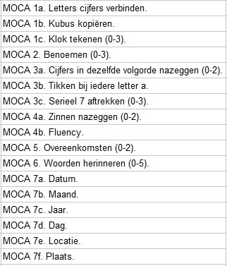

Subitems MMSE:
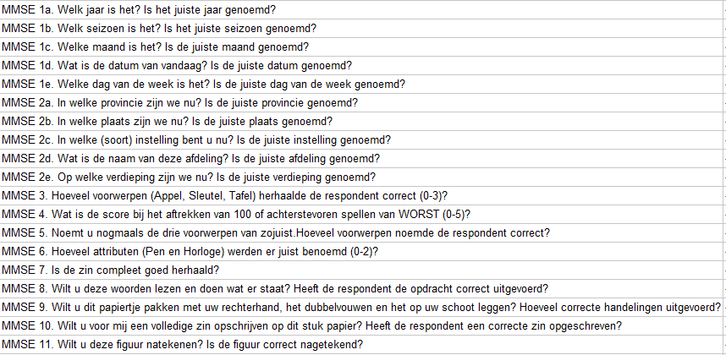

Van een deel van de cohorten zijn er uitgebreide neuropsychologische maten beschikbaar (denk aan fluency, 8/10/15-woordentest, Stroop, TMT, cijferreeksen).

Variables specific to ECT
Label | Description | Variable
ECTy | year of ECT course | Numeric year
ECTprov | ECT provided in which setting | 1 Admitted  2 Outpatient  3 Both
ECTdev | ECT device | 1 Thymatron (Somatics)  2 SpECTrum (Mecta)  3 Other
DoseMet | Dosingmethod | 1 Age  2 Titration
DoseBegin | Dose at beginning | Numeric  9999 missing | Hoogste dosis toegediend in de eerste sessie
DoseEnd | Dose at end | Numeric  9999 missing | Hoogste dosis toegediend in de laatste sessie
SeizTres | Seizurethreshold at beginning of the ECT course | Numeric  9999 missing | Dosis waarbij er voor het eerst een adequate seizure plaatsvindt: motor seizures > 15 seconds or EEG seizures > 25 seconds
EPbegin | Applied electrode placement at the beginning of the ECT course | 1 RUL: right-unilateral  2 BT: bitemporal  3 BF: bifrontal  9999 missing | Indien er staat ‘bilateraal’ kun je er vanuit gaan dat het bitemporaal is. Alleen bifrontaal noteren als dit er specifiek staat.
EPend | Applied electrode placement at the end of the ECT course | 1 RUL: right-unilateral  2 BT: bitemporal  3 BF: bifrontal  9999 missing | Indien er staat ‘bilateraal’ kun je er vanuit gaan dat het bitemporaal is. Alleen bifrontaal noteren als dit specifiek wordt genoemd.
PWbegin | Pulsewidth at the beginning of the ECT course | 0 0.3  1 0.5  2 1.0  9999 missing
PWend | Pulswidth at the end of the ECT course | 0 0.3  1 0.5  2 1.0  9999 missing
ESindex | Total number of ECT-sessions applied during the initial ECT-course | Numeric  9999 missing
RULindex | Total number of right-unilateral ECT-sessions applied during the initial ECT-course | Numeric  9999 missing
BTindex | Total number of bitemporal ECT-sessions applied during the initial ECT-course | Numeric  9999 missing | Indien er staat ‘bilateraal’ kun je er vanuit gaan dat het bitemporaal is (officieel heet het bifrontotemporaal).
BFindex | Total number of bifrontal ECT-sessions applied during the initial ECT-course | Numeric  9999 missing | Alleen bifrontaal noteren als dit specifiek wordt genoemd.
MECT | is index ECT course followed by M-ECT | 0 No  1 Yes  9999 missing | Start onderhoudskuur tot maximaal 2 weken na index kuur
SA | Seizure adequacy: operationalized by the percentage of sessions with motor seizures > 15 seconds or EEG seizures > 25 seconds | Numeric as percentage  9999 missing  9998 logical missing | Deze variabele wordt onderverdeeld in duur motor insult en duur EEG insult per sessie (in geval van herstimulatie wordt de hoogste duur meegenomen). S1_MI en S1_EEG t/m S40_M1 en S40_EEG.
Anes | Used anesthetics | 1 Etomidate with succinyl  2 Propofol with succinyl  3 Other  9999 missing
AnesOth | Other anesthetics | Text  9998 logical missing
DrOut | Drop-out during the ECT-course | 0 No  1 Yes  9999 missing
DrOutRea | Reason for drop-out during the ECT-course | Text  9998 logical missing

